Anyone Have an Average Penis and Still Get Girls?
Bodybuilding.com
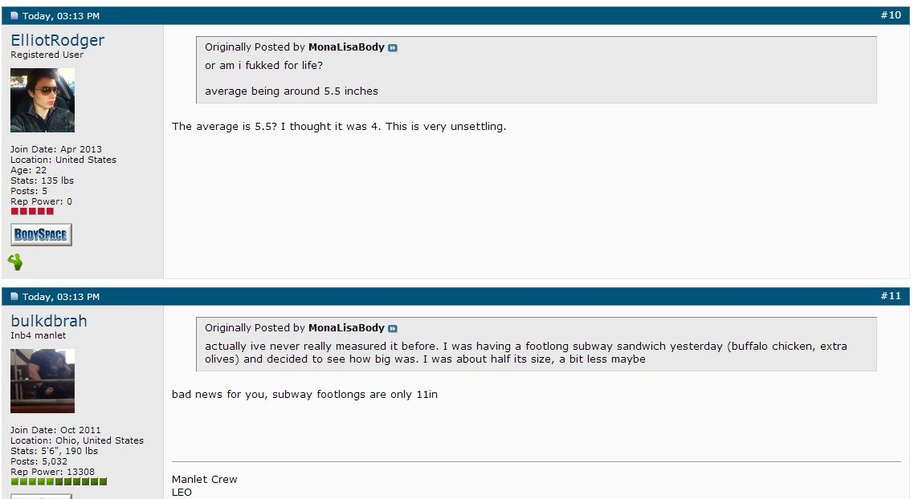

How Do You Deal with Hate?
Bodybuilding.com
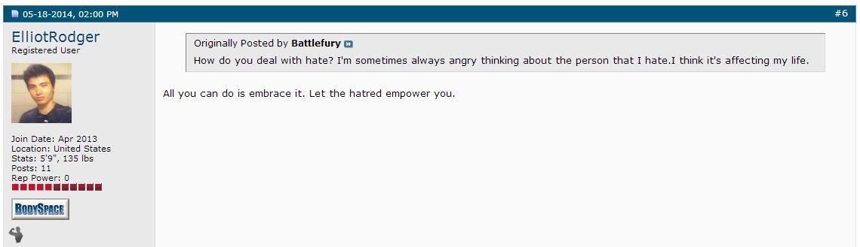

At What Point Did Men Lose All the Power?
Bodybuilding.com
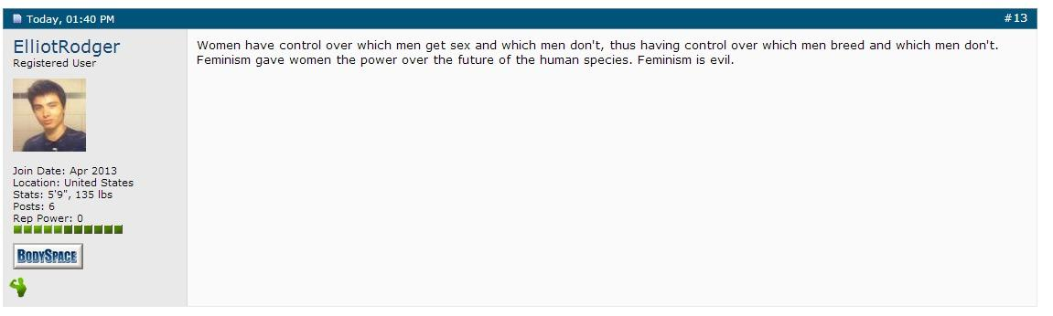

Elliot Rodgers Last Words to the MISC
Bodybuilding.com
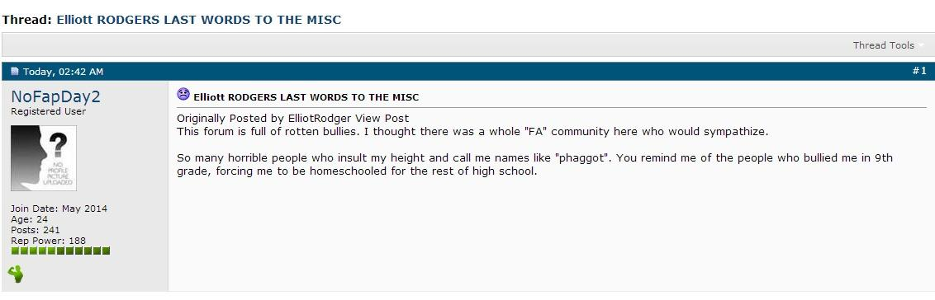
The above post comes from a Bodybuilding.com member who copied the text of Rodgers final post on Bodybuilding.com before it was scrubbed. I’m sure the bell is ringing reading the bullying and non-inclusive memes used in his final post.

