I Made a YouTube Vlog About Being FA
Bodybuilding.com

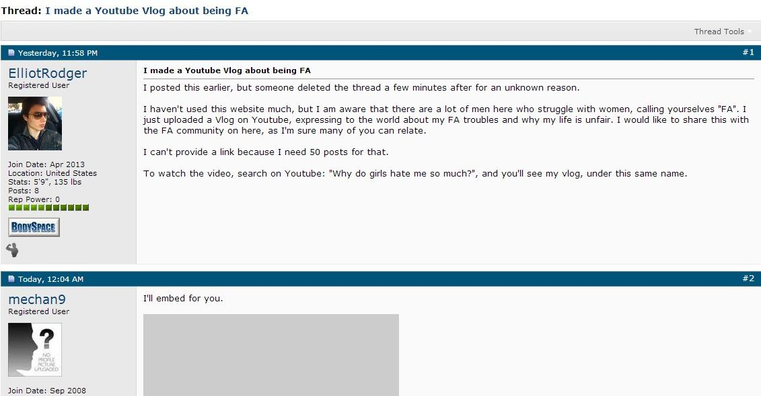

These Users Read Him Perfectly
