Elliot Rodger's Official Blog
http://elliotrodger.blogspot.com/

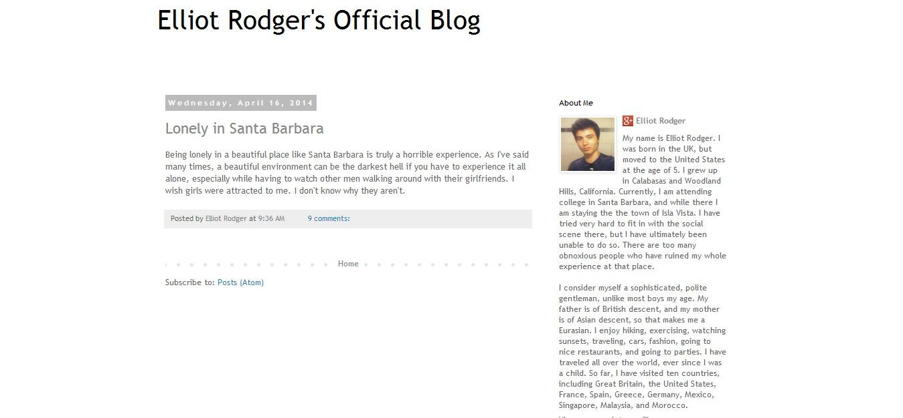
Cut and Paste of the Content in the screenshot above:

About Me

Elliot Rodger
My name is Elliot Rodger. I was born in the UK, but moved to the United States at the age of 5. I grew up in Calabasas and Woodland Hills, California. Currently, I am attending college in Santa Barbara, and while there I am staying the the town of Isla Vista. I have tried very hard to fit in with the social scene there, but I have ultimately been unable to do so. There are too many obnoxious people who have ruined my whole experience at that place.

I consider myself a sophisticated, polite gentleman, unlike most boys my age. My father is of British descent, and my mother is of Asian descent, so that makes me a Eurasian. I enjoy hiking, exercising, watching sunsets, traveling, cars, fashion, going to nice restaurants, and going to parties. I have traveled all over the world, ever since I was a child. So far, I have visited ten countries, including Great Britain, the United States, France, Spain, Greece, Germany, Mexico, Singapore, Malaysia, and Morocco.
View my complete profile

Wednesday, April 16, 2014

Lonely in Santa Barbara
Being lonely in a beautiful place like Santa Barbara is truly a horrible experience. As I've said many times, a beautiful environment can be the darkest hell if you have to experience it all alone, especially while having to watch other men walking around with their girlfriends. I wish girls were attracted to me. I don't know why they aren't.

